Hello,
Here are the instructions for mapping network drives:
1. In the search field, type “file explorer”. You’ll get an image similar to below:
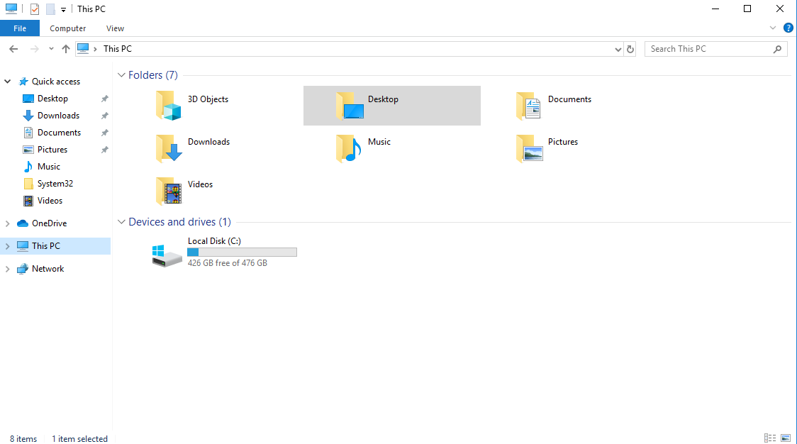
2. Click on the “This PC” section then click on the top option for “Computer”
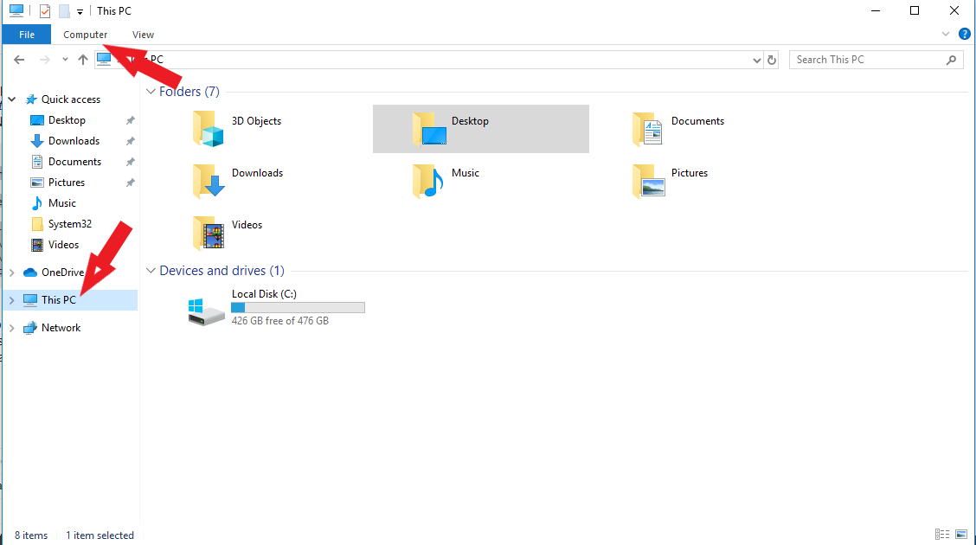

3.Click the “Map Network Drive” option and you’ll get this window:

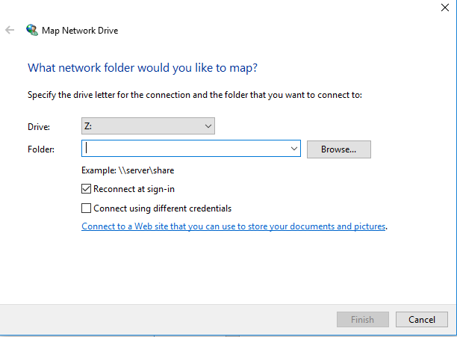
4. Now you can add all your drive by just choosing the appropriate letter and copy/paste the location in the “folder” field that’s everything including the “\\”, using the example provided it would be :
e.g - “\\tscd-apfil01wv.ad.tsc.edu\admissions”
e.g- “\\tscd-apfil01wv.ad.tsc.edu \first name.last name”
e.g- “\\tscd-apfil01wv.ad.tsc.edu \testing”
e.g- “\\tscd-apfil01wv.ad.tsc.edu \Financial Aid”

Then hit finish.

